April 2020

Dr Gary Hartnoll Ltd,
Company Number 11493468

This document sets out my current terms and conditions. These terms are reviewed annually in April. These terms will be the only terms which apply to any Appointment and may only be amended by agreement in writing.

Please confirm your acceptance by signing (both on behalf of your Client (as their authorised agent) and to confirm your obligations as Instructing Solicitors) and returning a copy of this letter. E-mail confirmation of acceptance of these terms and conditions is an acceptable alternative.

- Fees

  - My hourly rate is £250, except where legal aid rates are accepted.

  - My fee for appearing in court is £1800 per day.

  - All rates quoted are exclusive of VAT and subject to review annually.

  - I will charge all time spent in connection with this Appointment, including but not limited to, all investigations, preparing reports, and telephone or written attendance on your Client and/or Instructing Solicitors. Travel time from base will be charged at £50 per hour.

  - I will keep a note of the time that I spend on this matter and submit the same with my invoices.

  - All disbursements will be reimbursed. Disbursements will include travel, photocopying and reasonable accommodation and subsistence costs (as required). Any travel will only be within the United Kingdom and Ireland; rail and plane travel will be first class. Travel outside of the UK and Ireland will be by separate arrangement as required. I will provide your Client with receipted invoices in respect of all disbursements claimed.

  - I will invoice upon delivery of my report.

  - Invoices will be addressed to you and sent to your offices.

  - Where I am instructed as a Single Joint Expert by the solicitors of both parties, both firms of Instructing Solicitors will be jointly and severally liable for the fees and disbursements. Where I am instructed by an Agency which has itself been instructed by solicitors, both the Agency and its Instructing Solicitors will be jointly and severally liable for payment of the fees and disbursements.

  - If any payment due to me under the terms of the Appointment is not paid by the due date for payment (the “Due Date”), I reserve the right to charge interest which shall accrue on the overdue amount at the statutory rate. Such interest shall accrue on a daily basis from the Due Date until the date of actual payment, whether before or after judgment.

  - In the event of any court appearance being cancelled, for whatever reason, the full fee shall be paid unless I receive notification 7 days in advance. A cancellation charge of half the court fee per day booked will be paid where notification of cancellation is received with between 6 and 21 days notice, and 20% of the court fee per day booked will be paid if notification is received between 22 and 60 days in advance. In respect of notification received in advance of 61 days, all charges will be waived.

  - No charges will be payable in respect of a consultation or appointment with Instructing Solicitors and/or your Client where at least 48 hours’ notice of cancellation is given. If the consultation or appointment is cancelled less than 48 hours in advance, an administrative fee of £150 will be levied.

  - If your Client and/or Instructing Solicitors fail[s] to attend a consultation or appointment without notice, your Client shall pay on demand the sum of £500 by way of liquidated damages. The parties confirm that this sum represents a genuine pre-estimate of the loss of earnings that I would suffer in the event that your Client and/or Instructing Solicitors fail[s] to attend a consultation or appointment without notice.

- Instructing Solicitors’ Obligations

Instructing Solicitors:

  - are responsible for giving adequate instructions, and obtaining all relevant notes, records and investigations, and shall check that all relevant matters are addressed in the reports.

  - shall:

    - provide me with, or procure the provision of, all information which might reasonably be expected to be relevant in enabling me to fulfill my responsibilities under this Appointment (“Information”) as and when it becomes available to your Client and/or to Instructing Solicitors;

    - ensure that the Information provided or prepared by your Client or on your Client’s behalf is complete and accurate in all material aspects and not misleading and is updated as necessary (informing me immediately if your Client discovers or has reason to believe that any of the Information is, or becomes, untrue, incomplete, misleading or inaccurate in any material respect).

  - Instructing Solicitors acknowledge that I shall, and am entitled to, rely upon all Information provided to me, that I shall not be responsible for the accuracy or verification of any Information and that my report will be provided only on the basis of the Information disclosed to me by you.

  - confirm that my charges are no higher than reasonably necessary for the purpose of litigation bearing in mind my professional expertise and where necessary, that prior approval will be obtained from the Legal Aid Board or any other third party payor in respect of my charges.

  - agree to comply with and to take all reasonable steps to assist me in complying with the Protocol and the Civil Procedures Rules referred to in Clause 3.

- Duties to the Court

  - I confirm that I have read and will comply with the Protocol published by the Civil Justice Council, CPR35, PD35, and PD Pre-Action Conduct. In particular I understand that, although I owe a duty of care to your Client and Instructing Solicitors to exercise reasonable skill and care in carrying out their instructions, my primary duty as an expert witness is to provide independent and unbiased evidence to the Court.

- Insurance

  - I confirm that I hold professional indemnity insurance in respect of the Appointment.

- Right to Terminate

The Appointment is subject to receipt of all necessary and relevant information from you in sufficient time to prepare a response and payment of monthly invoices and/or the Fixed Fee as they fall due. I will advise you promptly if:

  - instructions are not acceptable because, for example, they require work that falls outside my expertise, impose unrealistic deadlines, or are insufficiently clear;

  - I consider that instructions are or have become insufficient to complete the work;

  - I become aware that I may not be able to fulfill any of the terms of Appointment; or

  - I am not satisfied that I can comply with any orders that have been made.

This retainer may be terminated by Instructing Solicitors or your Client at any time by written notice subject to discussion in accordance with the Protocol. Where I am instructed jointly termination will be effective when I have received written notice from all instructing parties. Termination will not affect my entitlement to payment of any fees for work conducted or invoiced before the date of the termination.

Upon termination, all documents and materials provided to me for the purpose of this Appointment must be returned promptly to Instructing Solicitors save for one copy that I may retain for my records.

- Intellectual Property

I will own the copyright in all reports and/or materials produced by me. Additionally, I will retain the title to all reports and/or materials produced by me until I have received full payment in accordance with paragraph 1.1 above. Subject to receipt of all payments due your Client is authorised to use the same for the purposes of the matters contained in the Schedule.

- Confidentiality

I will treat all information, facts, matters, documents and all other materials of a confidential nature which I receive or create as a result of this Appointment as confidential, (except insofar as I have to refer to them when setting out the substance of my instructions in your report or as required by law).

- Responsibility

I confirm that the work which is carried out in relation to this retainer will be my own and will not be delegated or sub-contracted to someone else.

- Conflict

You have notified me in writing of all parties who have some limited involvement in this matter including Counsel and solicitors and other experts already instructed in this case. I confirm that I do not have an actual or potential conflict of interest in accepting this Appointment in respect of any parties so named and that I will let you know without delay if I become aware of such a conflict.

- Joint Instructions

In circumstances where I am jointly instructed by Instructing Solicitors, both sets of Instructing Solicitors must sign and return a copy of this letter and completed schedule within seven days and ensure it is copied to all Instructing Solicitors. It is for Instructing Solicitors to resolve any disagreements the parties may have in relation to instructions or to clearly identify areas of disagreement in the Schedule.

- Governing Law

This Appointment is subject to English law and the parties hereto submit to the exclusive jurisdiction of the English courts.

- Force Majeure

I shall not be liable for any delay in the performance of any obligations under this Appointment (and the time for the performance of any obligations under this Appointment shall be extended accordingly) if such delay arises from or is attributable to acts, events, omissions or accidents beyond my reasonable control including but not restricted to, ill health, acts of God or of the public enemy, fires, floods, epidemics, riots, quarantine restrictions, strikes, freight embargoes, earthquakes, electrical outages, computer or communications failures, severe weather, and acts or omissions of subcontractors or third parties.

Please sign and return the enclosed copy letter to confirm acceptance of these terms and conditions [subject to my confirmation of acceptance]. In signing these terms for your Client, you warrant that you have all requisite full power and authority to do so both as agent for your Client(s) and in your own capacity to the extent that you undertake direct obligations.

Agreement to the terms and conditions by e-mail will be an acceptable alternative to a signed copy letter.

I will securely dispose of all records supplied to me (or return them to you, if requested) once instructed that the case is closed and/or no further reports from me will be required.

Yours sincerely

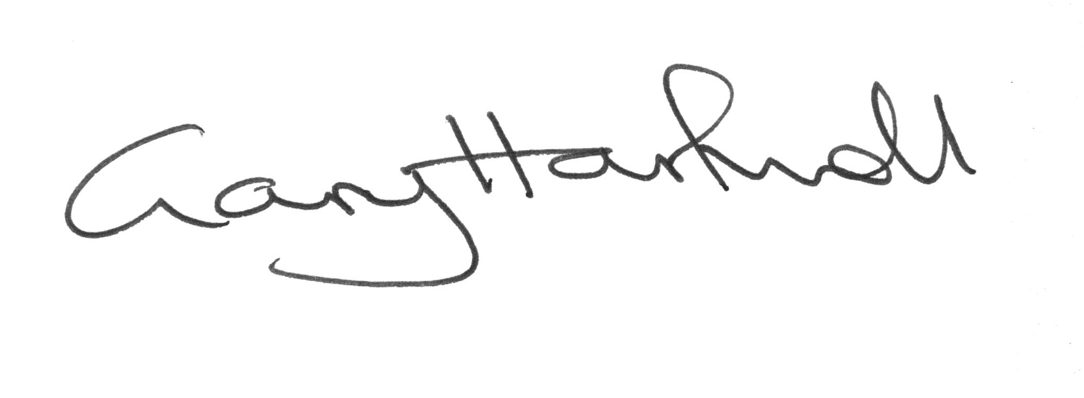
Gary Hartnoll
Consultant Neonatologist (Retired Dec 2019)
GMC 3143021

Director of Dr Gary Hartnoll Ltd
Registered office: 7 Lindum Terrace, Lincoln, Lincolnshire, England, LN2 5RP
Address for correspondence: BM Box 2512, London, WC1N 3XX

